The following headgear has been ruled illegal by the NFHS. 12/1/2016
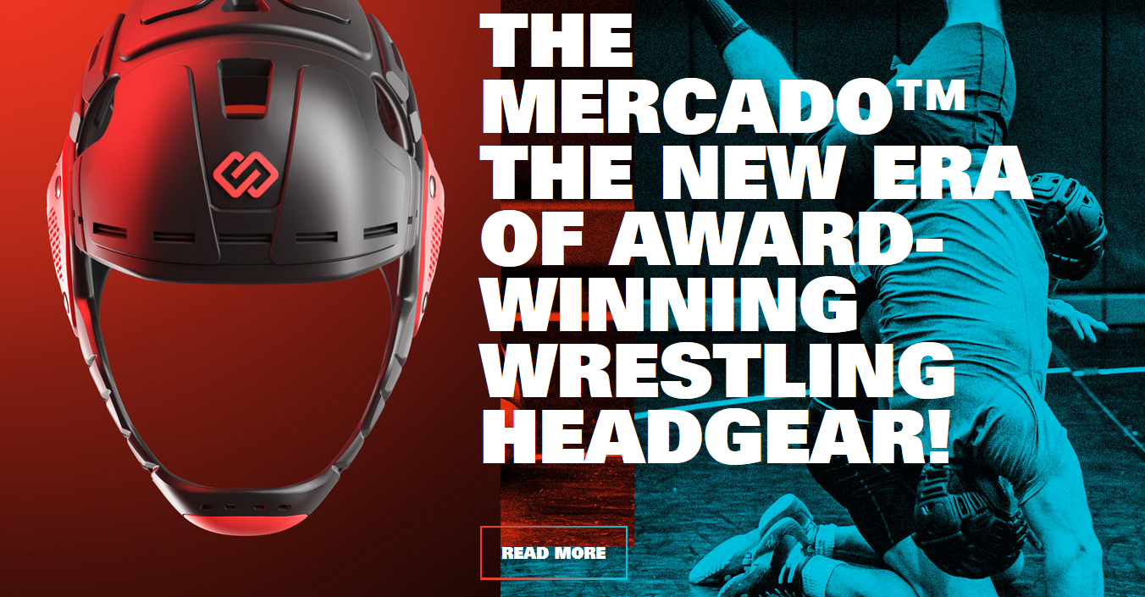
From: Dan Lang <dlang19@comcast.net>
Date: November 30, 2016 at 10:13:15 PM MST
Subject: Mercado headgear
All,
There is a newer headgear available called the “Mercado” manufactured by Batsoi. The NFHS has issued a ruling on the legality of this headgear earlier today. Per the NFHS, this particular headgear is not considered to be “legal” by the NFHS.
Here’s the website for this specific headgear for your reference:
http://batstoi.com
Please share this with your local officials and coaches.
As always, please let me know if you have any questions.
Regards,
Dan Lang
UIL State Rules Interpreter

